

AMERICAN INTERNATIONAL UNIVERSITY–BANGLADESH (AIUB)
FACULTY OF SCIENCE & TECHNOLOGY

INTRODUCTION TO DATABASE

Spring 2022-2023 Section: C Group: 03
Project Title

TOURISM MANAGEMENT SYSTEM

Supervised By
NYME AHMED

Submitted By

Name | ID | Contribution
1.Jahidul Haque Fahad | 22-47699-2 | Table Creation, Data Insertion, Conclusion
2. Md. Riyadh Ullah | 22-47725-2 | Normalization, Data Insertion, Query Writing
3.Shusmita Anjum Aziz | 22-47733-2 | ER Diagram, Finalization, Optimization, Query Writing
4. Md. Minhajun Nabi Shiam | 22-47830-2 | Introduction, Scenario, ER Diagram

TABLE OF CONTENTS
TOPICS
- Cover Page 01
- Table of Contents 02
- Introduction 03
- Scenario 03
- ER Diagram 04
- Normalization 05
- Finalization 14
- Optimization 15
- Table Creation 16
- Data Insertion 25
- Query Writing 35
13. Conclusion 40

INTRODUCTION:
In today’s fast-paced world, managing travel arrangements has become increasingly complex. Our project is based on a tourism management system which aims to establish a comprehensive and efficient solution for managing travel arrangements. By creating a centralized database, this project seeks to streamline the process of storing and retrieving critical travel information such as flight bookings, hotel reservations, food, transportation and so on. By successfully implementing this project, the travel industry can benefit from improved efficiency and seamless travel experience for both travel agencies and individual users.

SCENARIO:
In a tourism management system, a travel agency employs several employees to handle various tasks. Various types of employees work for a travel agency. A travel agency usually contains an agency ID, name, address, phone number and email address. On the other hand, an employee has an employee ID, name, date of birth, job type, salary, and different skills. Customers can approach a travel agency. A travel agency services many customers. A customer registers with a customer ID, name, address, phone number, email, and membership level. All kinds of addresses are composed of city, country and zip code. A customer makes payments for various facilities. A customer takes flights for travelling. A flight includes flight number, airline, departure and arrival which is composed by country and time. A customer uses various types of local transportation. Local transportation generally has transport number, booking date, pick-up location, drop-in location and mode of transport. Customers make reservations at hotels. A hotel offers accommodations, and the customer gets accommodations. To make accommodations, there is an accommodation ID, in date, out date, room type and room number. A hotel manages food booking. Different types of food bookings are offered by a hotel. Food booking is maintained by booking ID, booking date, meal type, and total number of guests. The payment process is tracked by payment ID, Amount, payment date, payment method, and invoice number.

ER DIAGRAM:

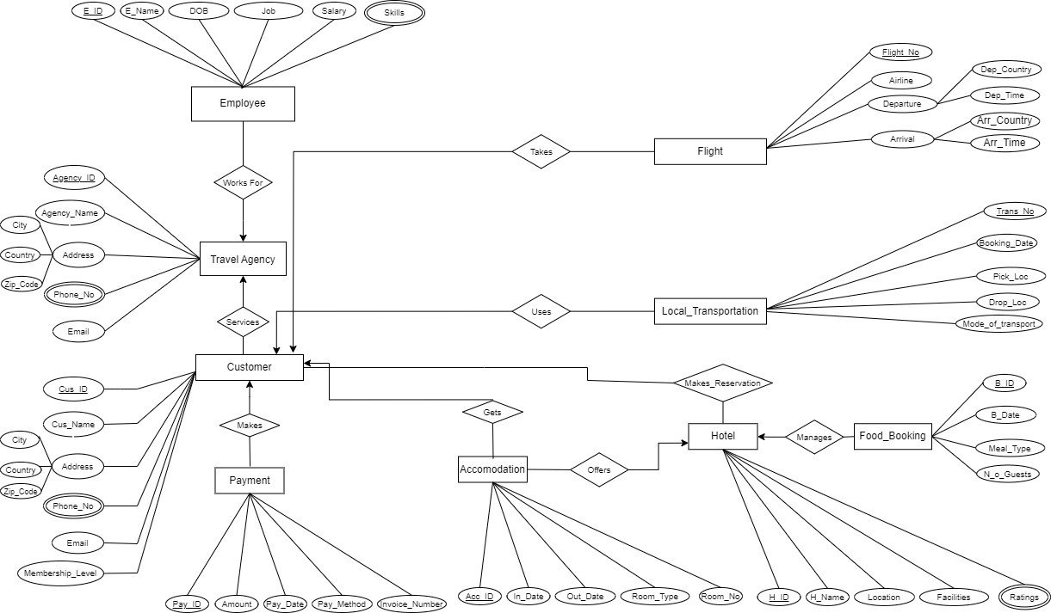

NORMALIZATION:
- Employee – works for – Travel Agency
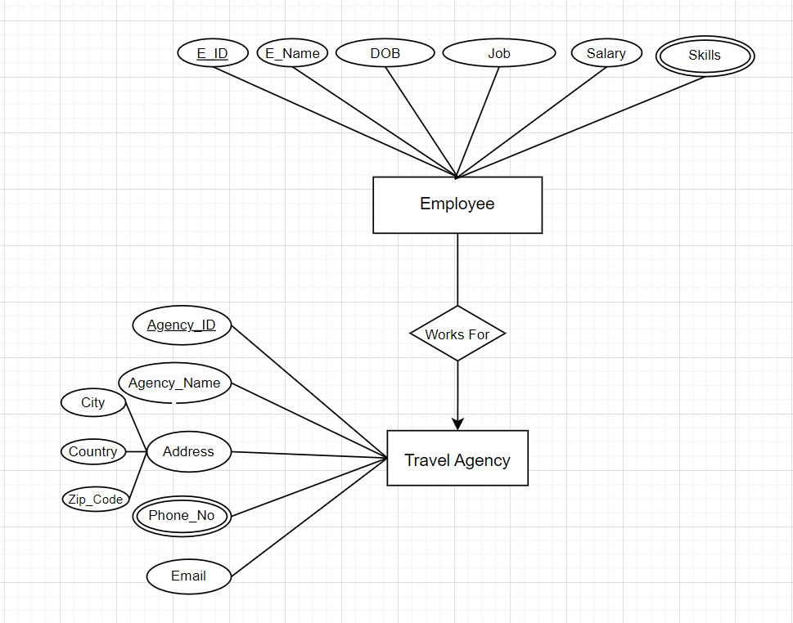

Relation: Many to One
UNF: Agency ID, Agency_Name, City, Country, Zip_code, Phone_No, Email, E_ID, E_Name, DOB, Job Title, Salary, Skills
1NF: Multivalued attributes: Phone_No, Skills.
Agency ID, Agency_Name, City, Country, Zip_code, Email, E_ID, E_Name, Date of Birth, Job Title, Salary

2NF: 1. Agency ID, Phone_No
- E_ID, Skills
- Agency ID, Agency_Name, City, Country, Zip_code, Email
- E_ID, E_Name, DOB, Job Title, Salary, Agency ID

3NF: 1. Agency ID, City, Country, Zip_code
- Agency ID, Phone_No
- E_ID, Skills
- Agency ID, Agency_Name, Email
- E_ID, E_Name, DOB, Job Title, Salary, Agency ID

- Travel Agency – services – Customer
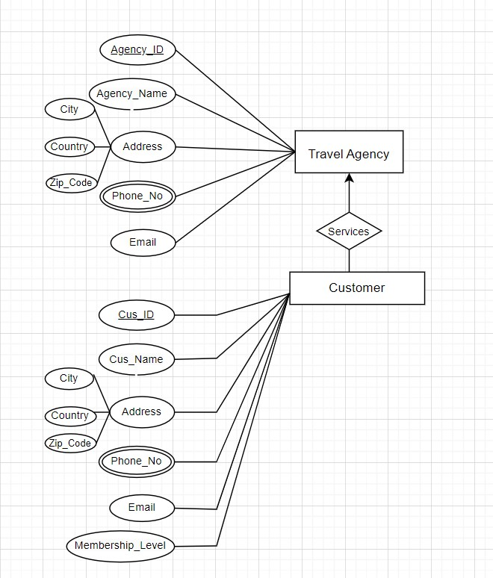

Relation: One to Many
UNF: Agency ID, Agency_Name, City, Country, Zip_code, Phone_No, Email, Cus_ID, Cus_Name, City, Country, Zip_code, Email, Phone_No, Membership_Level
1NF: Multivalued attributes: Phone_No, Phone_No.
Agency ID, Agency_Name, City, Country, Zip_code, Email, Cus_ID, Cus_Name, City, Country, Zip_code, Email, Membership_Level
2NF: 1. Agency ID, Phone_No
  - Cus_ID, Phone_No
  - Agency ID, Agency_Name, City, Country, Zip_code, Email
  - Cus_ID, Cus_Name, City, Country, Zip_code, Email, Membership_Level, Agency ID

3NF: 1. Agency ID, City, Country, Zip_code
- Cus_ID, City, Country, Zip_code
- Agency ID, Phone_No
- Cus_ID, Phone_No
- Agency ID, Agency_Name, Email
- Cus_ID, Cus_Name, Email, Membership_Level, Agency ID

- Customer – takes – Flight

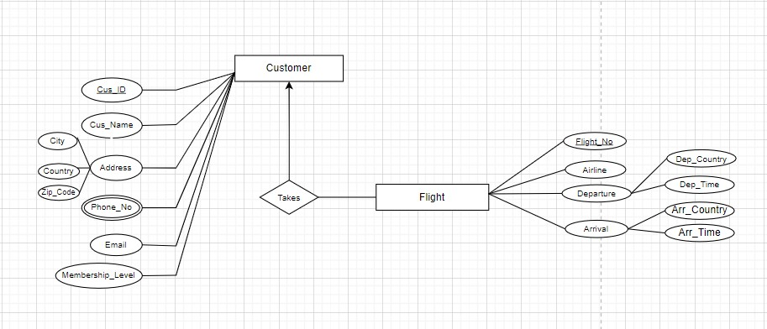
Relation: One to Many

UNF: Cus_ID, Cus_Name, City, Country, Zip_code, Email, phone_no, Membership_Level, Flight_No, Airline, Dep_Country, Arr_Country, Dep_Time, Arr_Time
1NF: Multivalued attributes: Phone_No
Cus_ID, Cus_Name, City, Country, Zip_code, Email, Membership_Level, Flight_No, Airline, Dep_Country, Arr_Country, Dep_Time, Arr_Time

2NF: 1. Cus_ID, Phone_No
  - Flight_No, Airline, Dep_Country, Arr_Country, Dep_Time, Arr_Time, Cus_ID
  - Cus_ID, Cus_Name, City, Country, Zip_code, Email, Membership_Level

3NF: 1. Cus_ID, Phone_No
- Flight_No, Dep_Country, Arr_Country, Dep_Time, Arr_Time
- Cus_ID, City, Country, Zip_code
- Cus_ID, Cus_Name, Email, Membership_Level
- Flight_No, Airline, Cus_ID

- Customer – uses – Local_Transportation

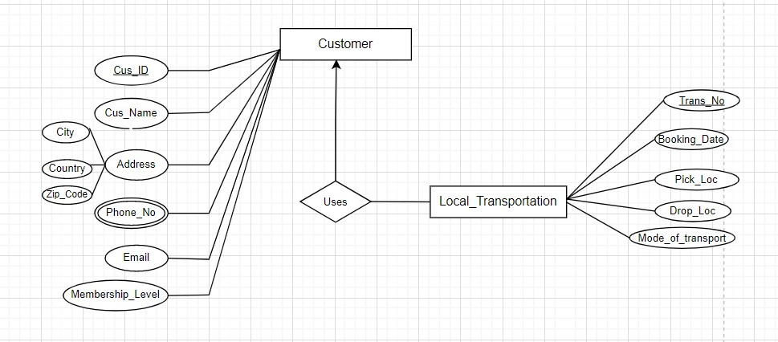

Relation: One to Many
UNF: Cus_ID, Cus_Name, City, Country, Zip_code, Email, Phone_No, Membership_Level, Trans_No, Booking_Date, Pick_Loc, Drop_Loc, Mode_of_Transport

1NF: Multivalued attributes: Phone_No
Cus_ID, Cus_Name, City, Country, Zip_code, Email, Membership_Level, Trans_No, Booking_Date, Pick_Loc, Drop_Loc, Mode_of_Transport

2NF: 1. Cus_ID, Phone_No
  - Trans_No, Booking_Date, Pick_Loc, Drop_Loc, Mode_of_Transport,

Cus_ID
  - Cus_ID, Cus_Name, City, Country, Zip_code, Email, Membership_Level
3NF: 1. Cus_ID, City, Country, Zip_code
- Cus_ID, Phone_No
- Trans_No, Booking_Date, Pick_Loc, Drop_Loc, Mode of Transport,

Cus_ID
- Cus_ID, Cus_Name, Email, Membership_Level

- Customer – makes_reservation – Hotel
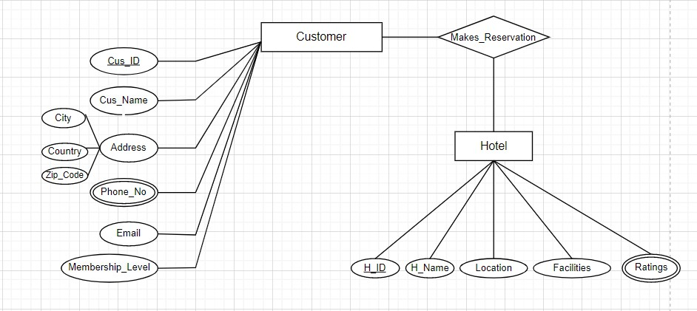
Relation: Many to Many

UNF: Cus_ID, Cus_Name, City, Country, Zip_code, Email, Phone_No, Membership_Level, H_ID, H_Name, Location, Facilites, Ratings
1NF: Multivalued attributes: Phone_No, Ratings
Cus_ID, Cus_Name, City, Country, Zip_code, Email, Phone_No, Membership_Level, H_ID, H_Name, Location, Facilites

2NF: 1. Cus_ID, Phone_No
  - H_ID, Ratings
  - Cus_ID, Cus_Name, City, Country, Zip_code, Email, Membership_Level
  - H_ID, H_Name, Location, Facilites, Cus_ID
3NF: 1. Cus_ID, City, Country, Zip_code
- Cus_ID, Phone_No
- H_ID, Ratings
- Cus_ID, Cus_Name, Email, Membership_Level
- H_ID, H_Name, Location, Facilites, Cus_ID

- Customer – gets - Accommodation
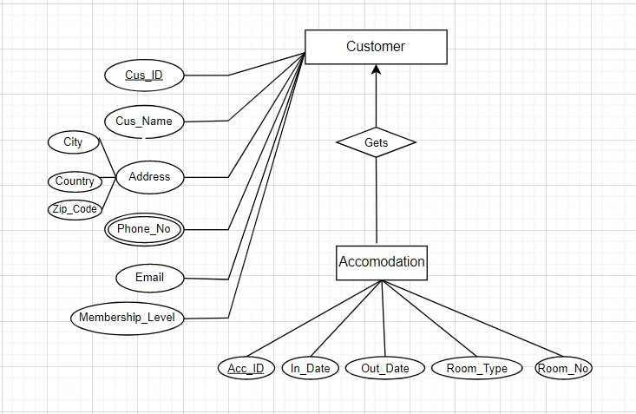

Relation: One to Many

UNF: Cus_ID, Cus_Name, City, Country, Zip_code, Email, phone_no, Membership_Level, Acc_ID, In_Date, Out_Date, Room_Type, Room_No

1NF: Multivalued attributes: Phone_No
Cus_ID, Cus_Name, City, Country, Zip_code, Email, Membership_Level, Acc_ID, In_Date, Out_Date, Room_Type, Room_No

2NF: 1. Cus_ID, Phone_No
  - Acc_ID, In_Date, Out_Date, Room_Type, Room_No, Cus_ID
  - Cus_ID, Cus_Name, City, Country, Zip_code, Email, Membership_Level

3NF: 1. Cus_ID, City, Country, Zip_code
- Cus_ID, Phone_No
- Cus_ID, Cus_Name, Email, Membership_Level
- Acc_ID, In_Date, Out_Date, Room_Type, Room_No, Cus_ID

- Hotel – offers – Accommodation

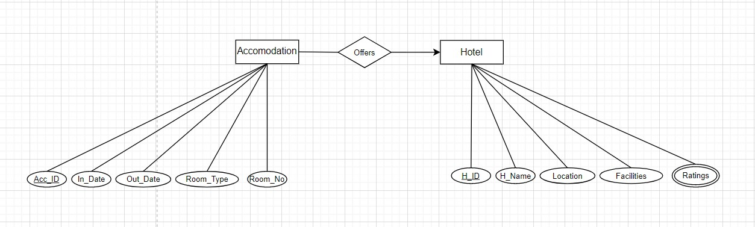

Relation: One to Many
UNF: Acc_ID, In_Date, Out_Date, Room_Type, Room_No, H_ID, H_name, location, Facilites, Ratings
1NF: Multivalued attributes: Ratings
Acc_ID, In_Date, Out_Date, Room_Type, Room_No, H_ID, H_name, location, Facilites

2NF: 1. H_ID, Ratings
  - Acc_ID, In_Date, Out_Date, Room_Type, Room_No, H_ID
  - H_ID, H_name, location, Facilites
3NF: 1. H_ID, Ratings
- Acc_ID, In_Date, Out_Date, Room_Type, Room_No, H_ID
- H_ID, H_name, location, Facilites

- Hotel – manages – Food_Booking
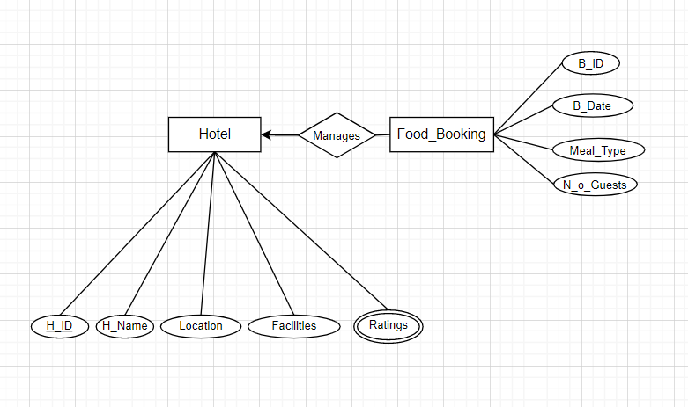

Relation: One to Many

UNF: H_ID, H_name, location, Facilites, Ratings, B_ID, B_Date, Meal_Type, N_o_Guests
1NF: Multivalued attributes: Ratings
H_ID, H_name, location, Facilites, B_ID, B_Date, Meal_Type, N_o_Guests

2NF: 1. H_ID, Ratings
  - H_ID, H_name, location, Facilites
  - B_ID, B_Date, Meal_Type, N_o_Guests, H_ID
3NF: 1. H_ID, Ratings
- H_ID, H_name, location, Facilites
- B_ID, B_Date, Meal_Type, N_o_Guests, H_ID

- Customer – makes – Payment

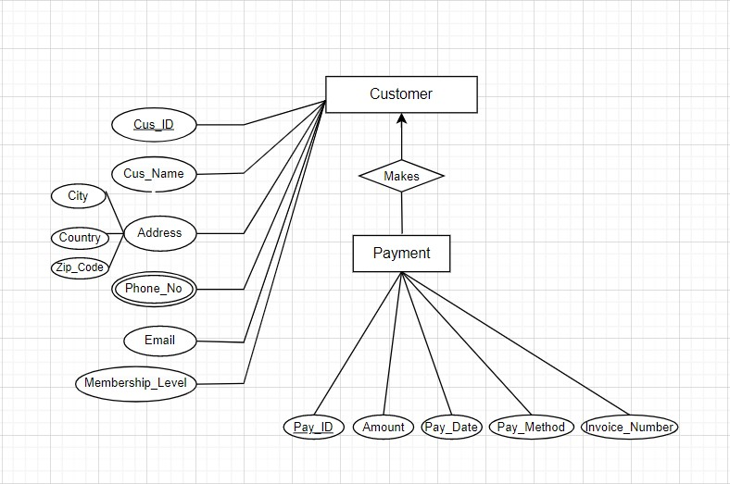

Relation: One to Many
UNF: Cus_ID, Cus_Name, City, Country, Zip_code, Email, phone_no, Membership_Level, Pay_ID, Amount, Pay_Date, Pay_Method, Invoice_Number, Phone_No
1NF: Multivalued attributes: Phone_No
Cus_ID, Cus_Name, City, Country, Zip_code, Email, Membership_Level, Pay_ID, Amount, Pay_Date, Pay_Method, Invoice_Number_Phone_No

2NF: 1. Cus_ID, Phone_No
  - Cus_ID, Cus_Name, City, Country, Zip_code, Email, Membership_Level
  - Pay_ID, Amount, Pay_Date, Pay_Method, Invoice_Number, Cus_ID

3NF: 1. Cus_ID, City, Country, Zip_code
- Cus_ID, Phone_No
- Cus_ID, Cus_Name, Email, Membership_Level
- Pay_ID, Amount, Pay_Date, Pay_Method, Invoice_Number, Cus_ID

FINALIZATION:
- Agency ID, City, Country, Zip_code
- Agency ID, Phone_No
- E_ID, Skills
- Agency ID, Agency_Name, Zip_code, Email
- E_ID, E_Name, DOB, Job Title, Salary, Agency ID
- Agency ID, City, Country, Zip_code
- Cus_ID, City, Country, Zip_code
- Agency ID, Phone_No
- Cus_ID, Phone_No
- Agency ID, Agency_Name, Email
- Cus_ID, Cus_Name, Email, Membership_Level, Agency ID
- Cus_ID, City, Country, Zip_code
- Cus_ID, Phone_No
- Trans_No, Booking_Date, Pick_Loc, Drop_Loc, Mode of Transport,

Cus_ID
- Cus_ID, Cus_Name, Email, Membership_Level
- Cus_ID, City, Country, Zip_code
- Cus_ID, Phone_No
- H_ID, Ratings
- Cus_ID, Cus_Name, Email, Membership_Level
- H_ID, H_Name, Location, Facilites, Cus_ID
- Cus_ID, City, Country, Zip_code
- Cus_ID, phone_no
- Cus_ID, Cus_Name, Email, Membership_Level
- Pay_ID, Amount, Pay_Date, Pay_Method, Invoice_Number, Cus_ID
- H_ID, Ratings
- H_ID, H_name, location, Facilites
- B_ID, B_Date, Meal_Type, N_o_Guests, H_ID
- Cus_ID, City, Country, Zip_code
- Cus_ID, phone_no
- Cus_ID, Cus_Name, Email, Membership_Level
- Acc_ID, In_Date, Out_Date, Room_Type, Room_No, Cus_ID
- H_ID, Ratings
- Acc_ID, In_Date, Out_Date, Room_Type, Room_No, H_ID
- H_ID, H_name, location, Facilites
- Cus_ID, Phone_No
- Flight_No, Dep_Country, Arr_Country, Dep_Time, Arr_Time
- Cus_ID, City, Country, Zip_code
- Cus_ID, Email, Membership_Level
- Flight_No, Airline, Cus_ID

OPTIMIZATION:

- Agency ID, City, Country, Zip_code – (Agency_Loc)
- Agency ID, Phone_No – (Agency_Con)

- Agency ID, Agency_Name, Email – (Agency_Info)

- E_ID, Skills – (EMP_Skill)
- E_ID, E_Name, DOB, Job Title, Salary, Agency ID – (EMP_Info)

- Cus_ID, City, Country, Zip_code – (CUS_Loc)
- Cus_ID, Phone_No – (Cus_Con)
- Cus_ID, Cus_Name, Email, Membership_Level, Agency ID – (CUS_Info)

- Flight_No, Dep_Country, Arr_Country, Dep_Time, Arr_Time –
(Airline_Info)
- Flight_No, Airline, Cus_ID – (Airline)
- Trans_No, Booking_Date, Pick_Loc, Drop_Loc, Mode_of _Transport,
Cus_ID - (Transportation)
- H_ID, H_Name, Location, Facilites, Cus_ID – (Hotel_Info)
- H_ID, Ratings – (Hotel_Ratings)
- Acc_ID, In_Date, Out_Date, Room_Type, Room_No, Cus_ID, H_ID
– (Accommodation)

- B_ID, B_Date, Meal_Type, N_o_Guests, H_ID – (Food_Booking)
- Pay_ID, Amount, Pay_Date, Pay_Method, Invoice_Number, Cus_ID - (Payment)

TABLE CREATION:

Agency_Info :
create table Agency_Info(Agency_ID varchar2(20) primary key,Agency_Name varchar2(20) not null,Email varchar2(20) unique)
desc Agency_Info
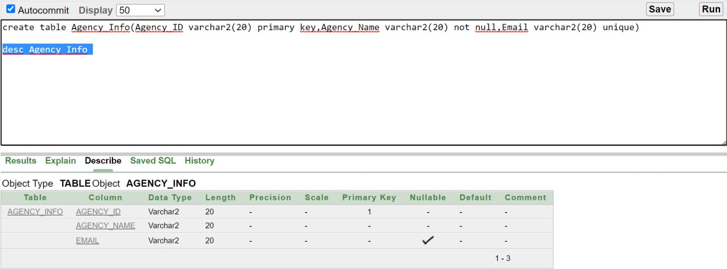

Agency_Loc :
create table Agency_Loc(Agency_ID varchar2(20) primary key,City varchar2(20) not null,Country varchar2(20) not null,Zip_code number not null)

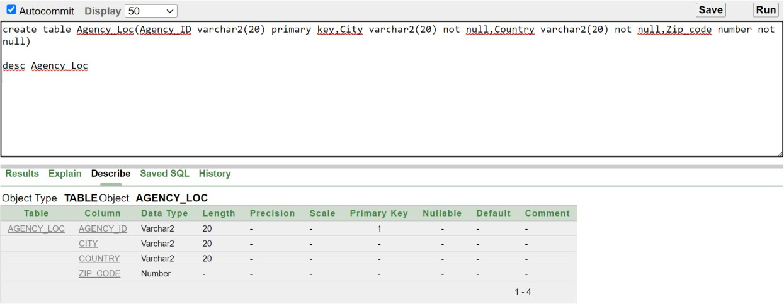
desc Agency_Loc

Agency_con
CREATE TYPE multivalue_type AS TABLE OF VARCHAR2(15); CREATE TABLE Agency_Con ( Agency_ID varchar2(20) PRIMARY KEY, Phone_No multivalue_type) NESTED TABLE Phone_No STORE AS Phone_Numbers_Table;

desc Agency_con
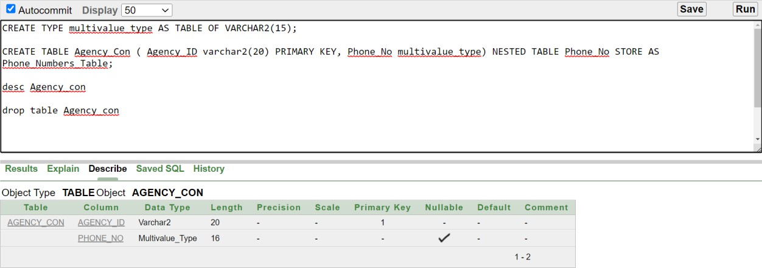
drop table Agency_con

EMP_Info :
create table EMP_Info(E_ID varchar2(20) primary key,E_Name varchar2(20) not null,DOB date not null,Job_Title varchar2(20) not null,Salary Number(20) not null,Agency_ID varchar2(20) not null )
ALTER TABLE EMP_Info ADD foreign key (Agency_ID) references Agency_Info (Agency_ID)
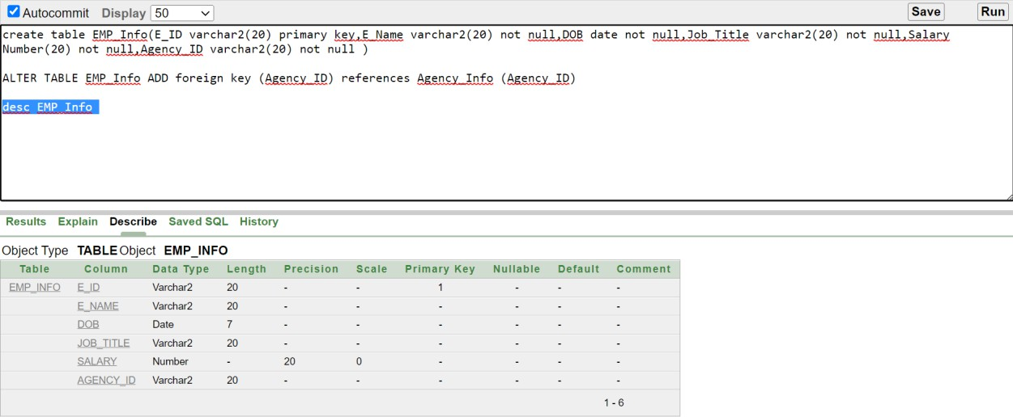
desc EMP_Info

EMP_Skill :
CREATE TYPE multivalue_type AS TABLE OF VARCHAR2(15);
CREATE TABLE EMP_Skill ( E_ID varchar2(20) PRIMARY KEY, skills multivalue_type) NESTED TABLE skills STORE AS Phone_Numbers_Table4;
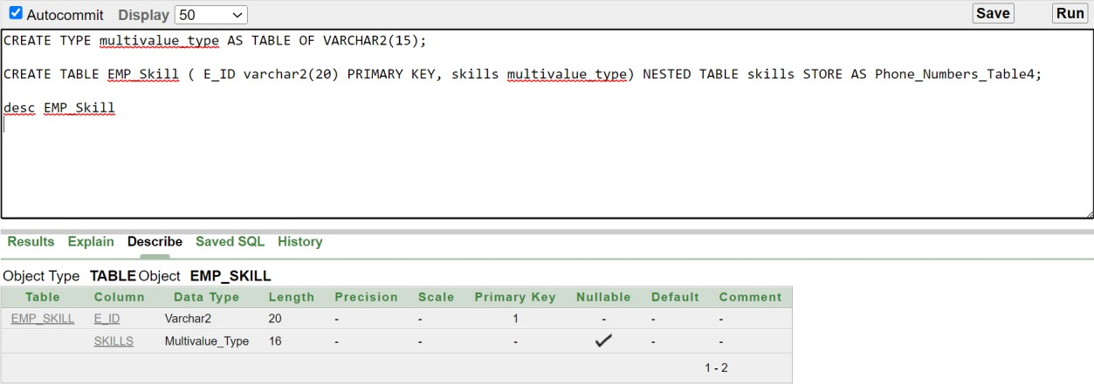
desc EMP_Skill

CUS_Info
CREATE TABLE CUS_Info(CUS_ID varchar2(20) PRIMARY KEY,
Cus_Name varchar2(100) NOT NULL, Email varchar2(100) UNIQUE, Membership_Level varchar2(20), Agency_ID varchar2(20));
ALTER TABLE CUS_Info add constraint agency FOREIGN KEY (Agency_ID) references Agency_Info (Agency_ID) ;
DESC CUS_Info;
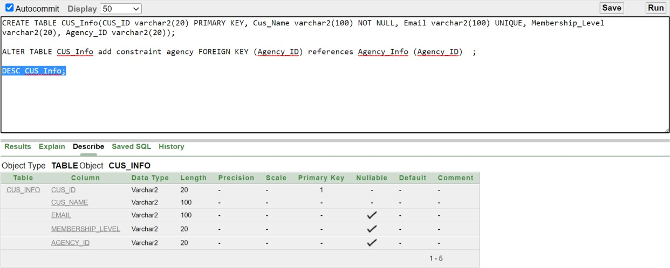

CUS_Loc
CREATE TABLE CUS_Loc(CUS_ID varchar2(20) PRIMARY KEY, country varchar2(20) NOT NULL, city varchar2(20) NOT NULL, Zip_Code varchar2(20));
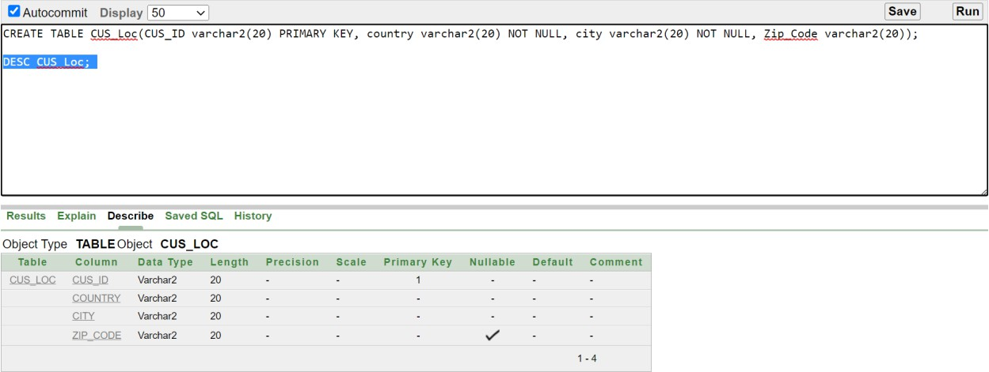
DESC CUS_Loc;

CUS_con
CREATE TYPE multivalue_type AS TABLE OF VARCHAR2(15); CREATE TABLE cus_con ( cus_id varchar(20) PRIMARY KEY, Phone_No multivalue_type) NESTED TABLE Phone_No STORE AS Phone_Numbers_Table1;

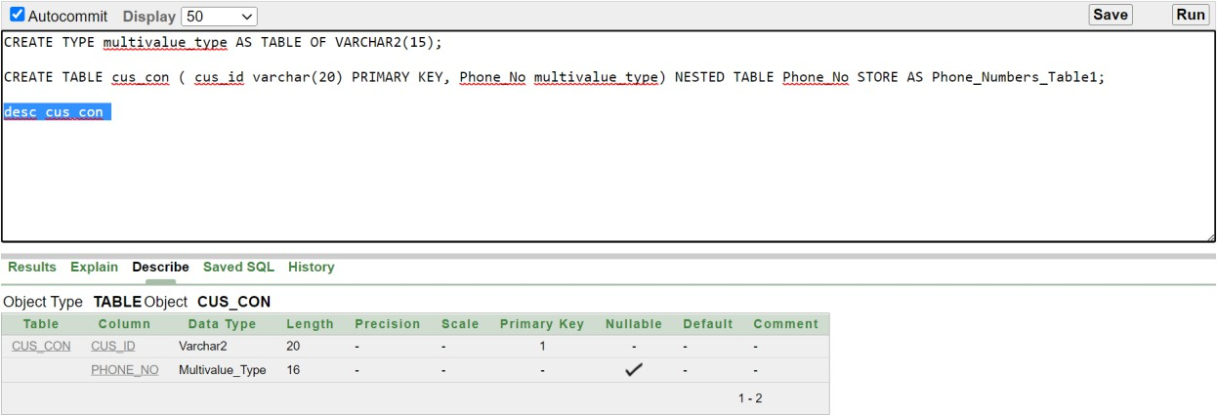
desc cus_con

Airline:
create table Airline(Flight_No Varchar2(20) primary key,Airline varchar2(20) not null,Cus_ID varchar2(20) not null)

ALTER TABLE Airline ADD foreign key (Cus_Id) references Cus_Info(Cus_Id)
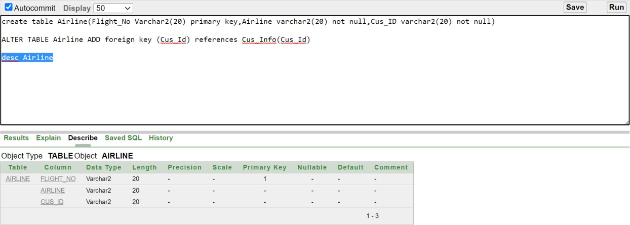
desc Airline;

Airline_Info:
create table Airline_Info(Flight_No Varchar2(20) primary key,Dep_Country varchar2(20) not null,Arr_Country varchar2(20) not null,Dep_Time varchar(20) not null,Arr_Time Varchar2(20) not null)
desc Airline_Info
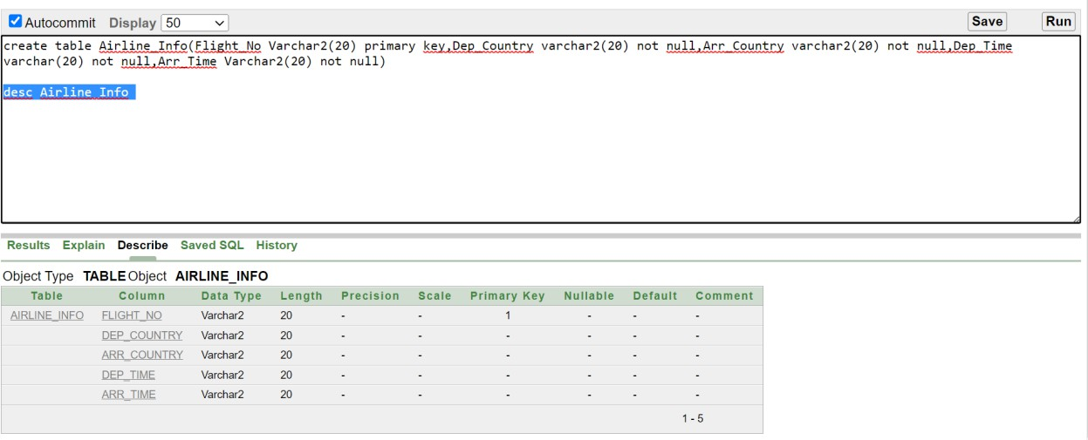

Transportation
CREATE TABLE transportation (Trans_No varchar(20) PRIMARY KEY, Booking_Date date UNIQUE, Pick_Loc varchar(20) NOT NULL, Drop_Loc varchar(20) NOT NULL, Mode_of_Transport varchar(10), CUS_ID varchar2(20))

ALTER TABLE transportation add constraint customers FOREIGN KEY (CUS_ID) references CUS_Info (CUS_ID)
DESC transportation
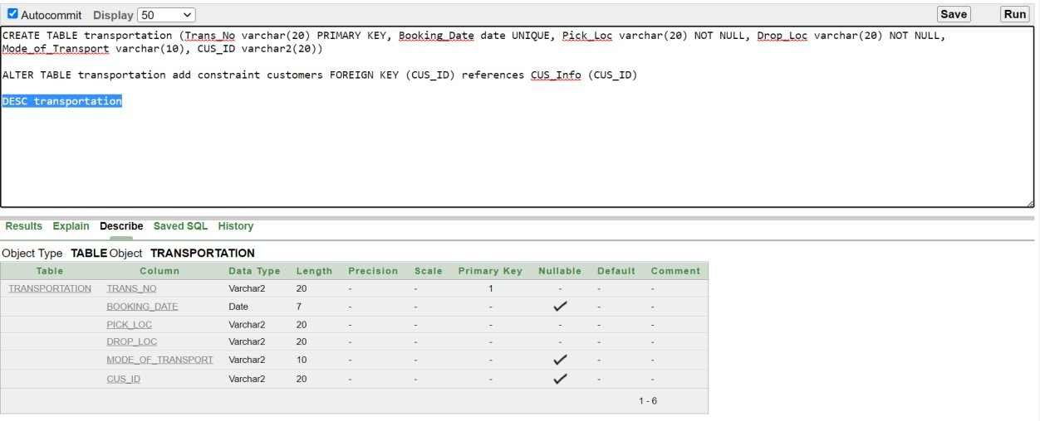

Hotel_Info :
create table Hotel_Info(H_ID Varchar2(20) primary key,H_Name varchar2(20) not null,Location varchar2(20) not null,Facilites varchar2(20) not null,Cus_ID varchar2(20) not null)

ALTER TABLE Hotel_Info ADD foreign key (Cus_Id) references Cus_Info(Cus_Id)

desc Hotel_Info

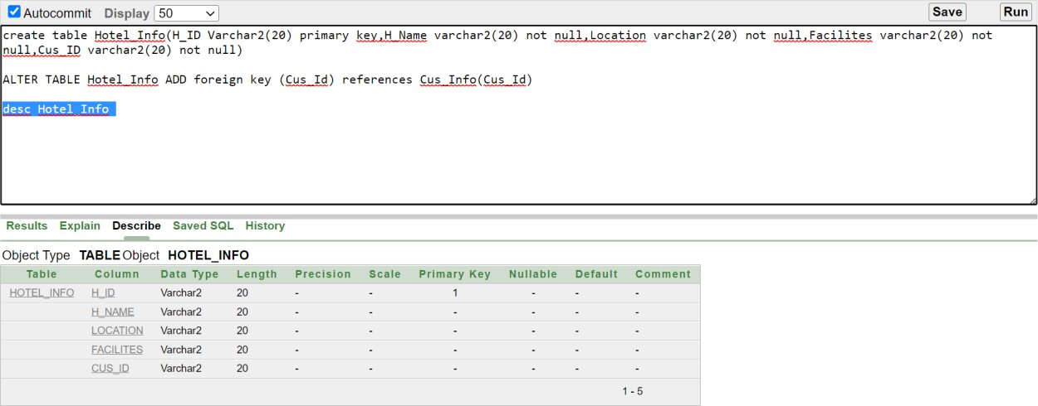

Accommodation
CREATE TABLE Accommodation(ACC_ID varchar2(20) PRIMARY KEY,In_Date date NOT NULL, Out_Date date NOT NULL, Room_Type varchar2(20), Room_No number(7,0) UNIQUE, CUS_ID varchar2(20), H_ID varchar2(20));

ALTER TABLE Accommodation add constraint customer1 FOREIGN KEY (CUS_ID) references CUS_Info;

ALTER TABLE Accommodation add constraint hotel FOREIGN KEY (H_ID) references Hotel_Info;
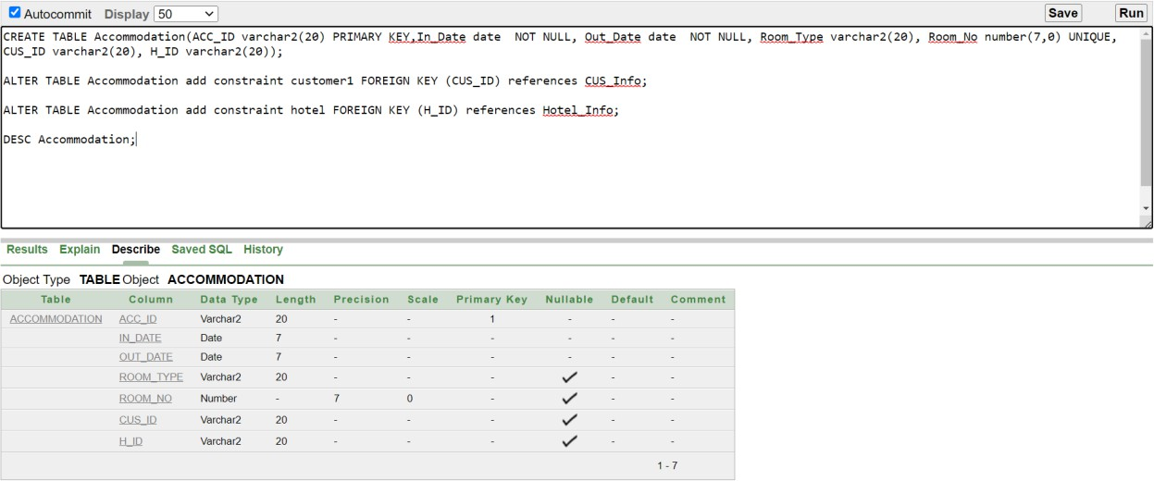
DESC Accommodation;

Food_Booking:
create table Food_Booking(B_ID Varchar2(20) primary key,B_Date varchar2(20) not null,Meal_Type varchar2(20) not null,N_o_Guests varchar2(20) not null,H_ID varchar2(20) not null)
ALTER TABLE Food_Booking ADD foreign key (H_ID ) references Hotel_Info (H_ID )
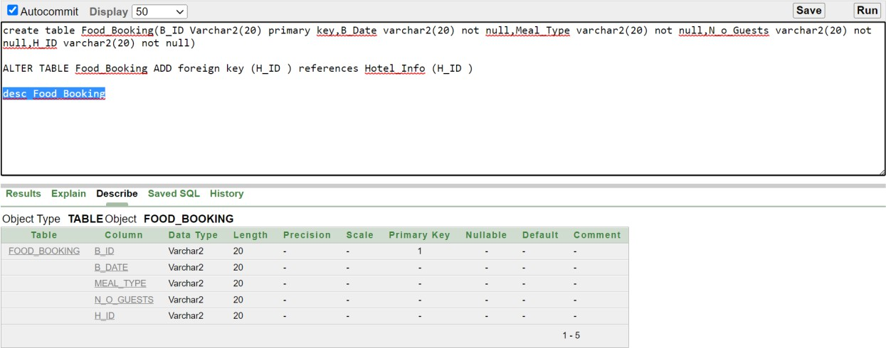
desc Food_Booking;

- Hotel_Ratings
CREATE TYPE multivalue_type AS TABLE OF VARCHAR2(15); CREATE TABLE Hotel_Ratings ( H_ID varchar2(20) PRIMARY KEY, Ratings multivalue_type) NESTED TABLE Ratings STORE AS Phone_Numbers_Table3;

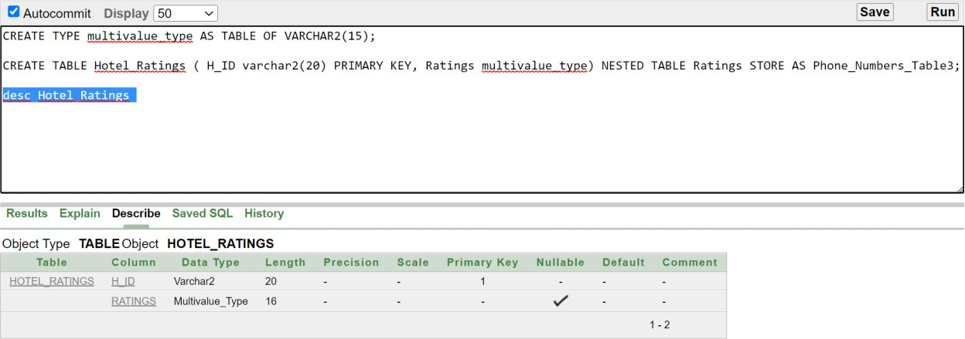
desc Hotel_Ratings

Payment :
create table Payment(Pay_ID varchar2(20) primary key,Amount number not null,Pay_Date date not null,Pay_Method varchar(20) not null,Invoice_Number Number not null,Cus_Id varchar2(20) not null)
ALTER TABLE Payment ADD foreign key (Cus_Id) references Cus_Info(Cus_Id)
desc Payment
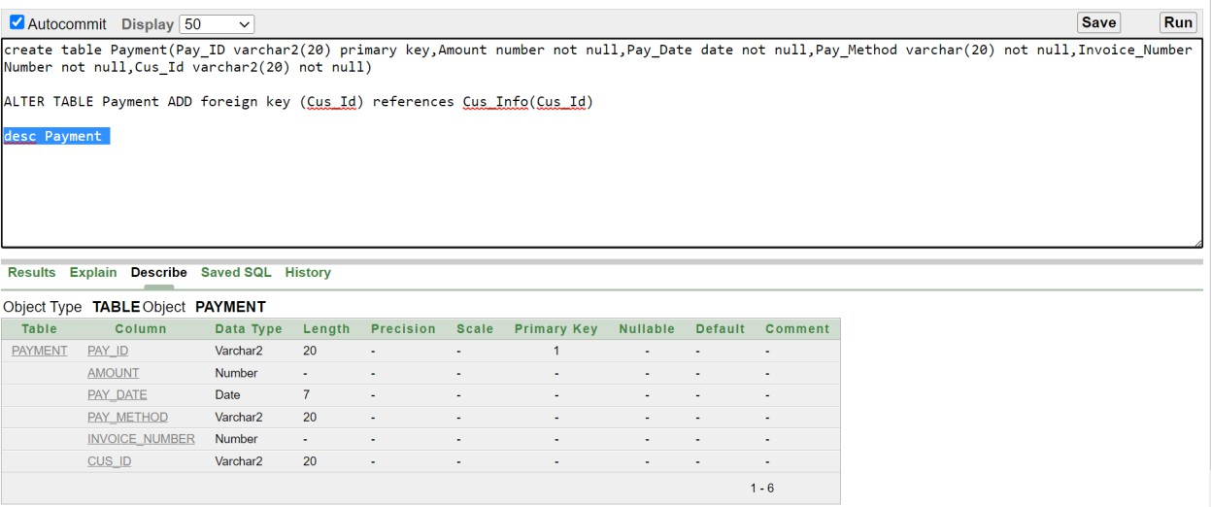

DATA INSERTION:

Agency_Info
desc Agency_Info

insert into Agency_Info ( AGENCY_ID, AGENCY_NAME, EMAIL) values('101-A', 'ABC', 'abc@gmail.com')
insert into Agency_Info ( AGENCY_ID, AGENCY_NAME, EMAIL) values('101-B', 'XYZ', 'XYZ@gmail.com')
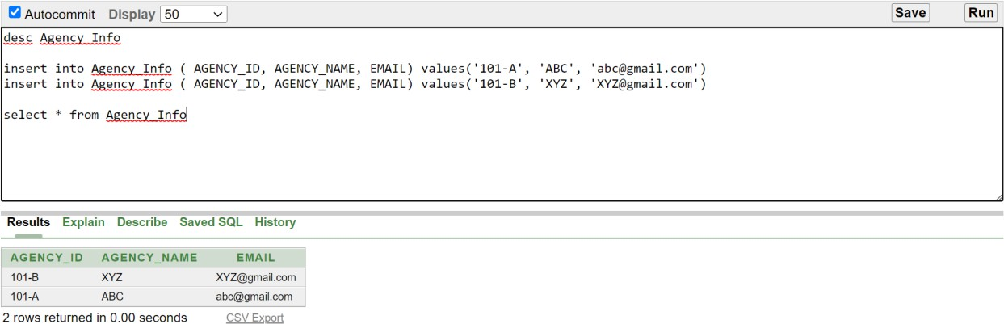
select * from Agency_Info

Agency_Loc
desc Agency_Loc
insert into Agency_Loc ( AGENCY_ID, CITY, COUNTRY, ZIP_CODE) values('101-A', 'DHAKA', 'BANGLADESH',100)
insert into Agency_Loc ( AGENCY_ID, CITY, COUNTRY, ZIP_CODE) values('101-B', 'CUMILLA', 'BANGLADESH',200)
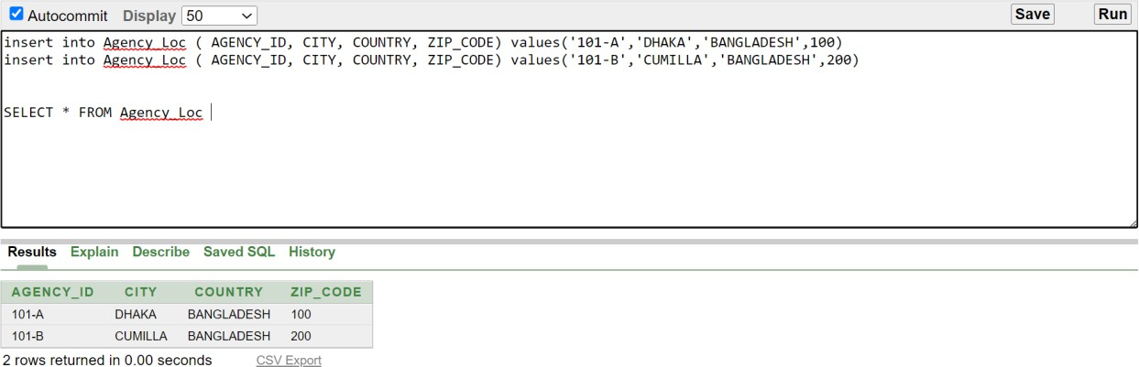
SELECT * FROM Agency_Loc

Agency_con
desc Agency_con
INSERT INTO Agency_Con (Agency_ID, Phone_No) VALUES ('101-A', multivalue_type('017*********', '016*********'));
INSERT INTO Agency_Con (Agency_ID, Phone_No) VALUES ('101-B', multivalue_type('017543******', '016245******'));

SELECT Agency_ID, COLUMN_VALUE AS Phone_No FROM Agency_Con, TABLE(Agency_Con.Phone_No);
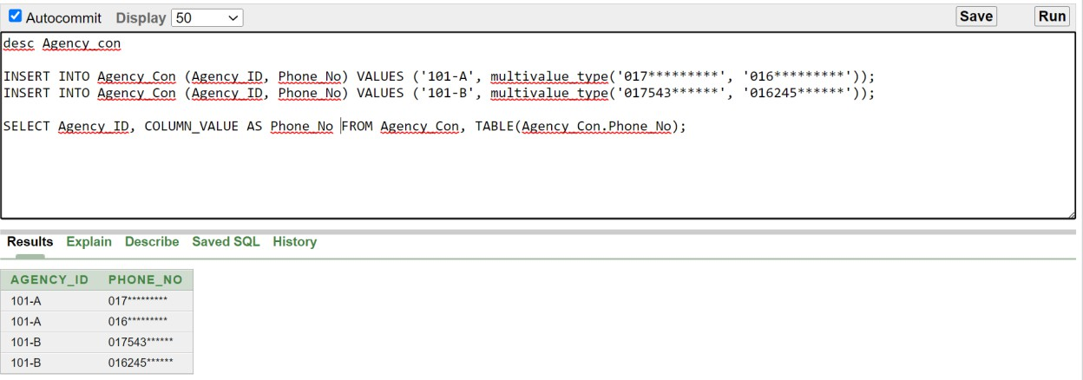

EMP_Info
desc EMP_Info
insert into EMP_Info( E_ID, E_NAME, DOB, JOB_TITLE, SALARY, AGENCY_ID) values('1','FAHAD', '17-DEC-02', 'MANAGER', 10000, '101- A')
insert into EMP_Info( E_ID, E_NAME, DOB, JOB_TITLE, SALARY, AGENCY_ID) values('2','RIYADH', '16-MAY-01', 'CEO', 10000, '101-A')
insert into EMP_Info( E_ID, E_NAME, DOB, JOB_TITLE, SALARY, AGENCY_ID) values('3','SHUSMITA', '03-JUN-01', 'GUIDE', 20000, '101-A')
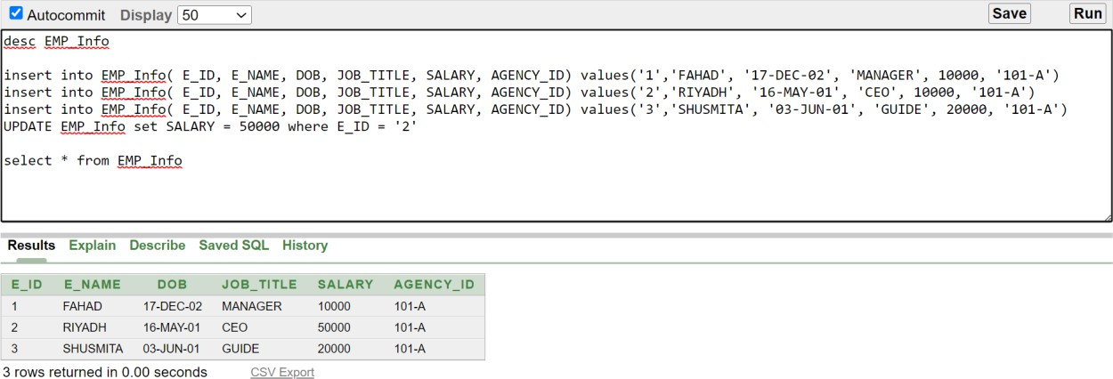
UPDATE EMP_Info set SALARY = 50000 where E_ID = '2' select * from EMP_Info

EMP_Skill
desc EMP_Skils
INSERT INTO EMP_Skill (E_ID, SKILLS) VALUES ( '1', multivalue_type('COMMUNICATION', 'TIME MANAGEMENT')); INSERT INTO EMP_Skill (E_ID, SKILLS) VALUES ( '2', multivalue_type('ORGANIZATION', 'PROBLEM SOLVING')); INSERT INTO EMP_Skill (E_ID, SKILLS) VALUES ( '3',
multivalue_type('LANGUAGE SKILLS'));
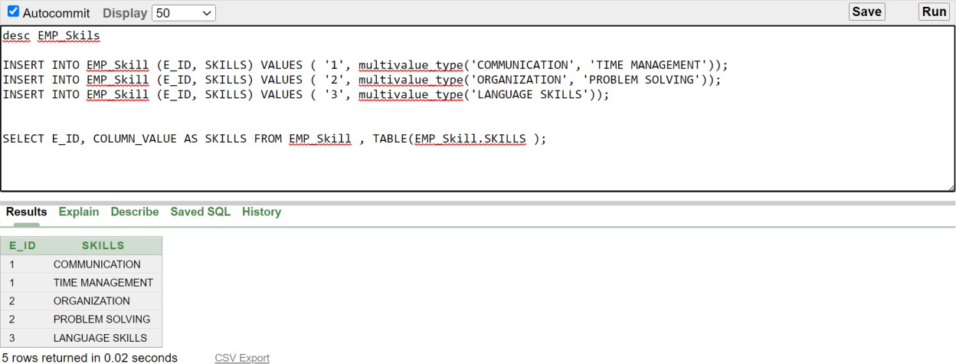
SELECT E_ID, COLUMN_VALUE AS SKILLS FROM EMP_Skill , TABLE(EMP_Skill.SKILLS );

CUS_Info
DESC CUS_Info;
insert into CUS_Info( CUS_ID, CUS_NAME, EMAIL, MEMBERSHIP_LEVEL, AGENCY_ID) values('10', 'ANJUM',
'anjum@gmail.com', 'PREMIUM','101-A')
insert into CUS_Info( CUS_ID, CUS_NAME, EMAIL, MEMBERSHIP_LEVEL, AGENCY_ID) values('20', 'RAISUL',
'raisul@gmail.com', 'PREMIUM','101-A')
insert into CUS_Info( CUS_ID, CUS_NAME, EMAIL, AGENCY_ID) values('30', 'SIAM', 'siam@gmail.com','101-A')
select * from CUS_Info

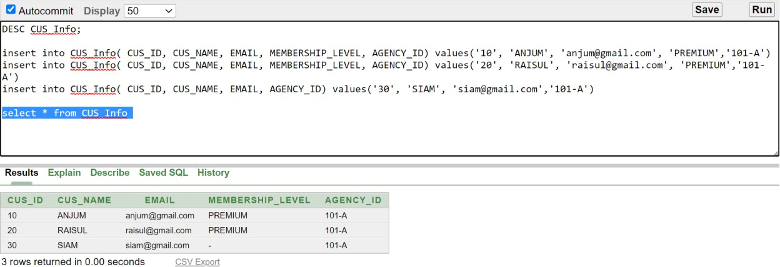

CUS_Loc
DESC CUS_Loc;

insert into CUS_Loc( CUS_ID, COUNTRY, CITY, ZIP_CODE) values('10','BANGLADESH', 'MYMENSINGH', '2200')
insert into CUS_Loc( CUS_ID, COUNTRY, CITY, ZIP_CODE) values('20','BANGLADESH', 'CUMILLA', '3500')
insert into CUS_Loc( CUS_ID, COUNTRY, CITY, ZIP_CODE) values('30','BANGLADESH', 'LAKSHAM', '3570')

select * from CUS_Loc
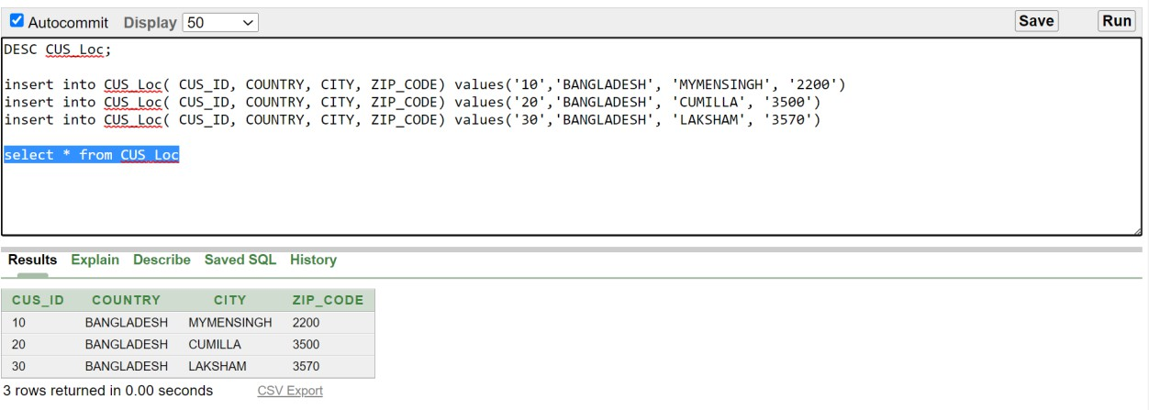

CUS_Con
DESC cus_con;
INSERT INTO cus_con(CUS_ID, PHONE_NO) VALUES ( '10',
multivalue_type('018********', '019********'));
INSERT INTO cus_con(CUS_ID, PHONE_NO) VALUES ( '20',
multivalue_type('01811******', '01822******'));
INSERT INTO cus_con(CUS_ID, PHONE_NO) VALUES ( '30',
multivalue_type('018123*****', '015678*****', '016********'));

SELECT CUS_ID, COLUMN_VALUE AS PHONE_NO FROM cus_con ,
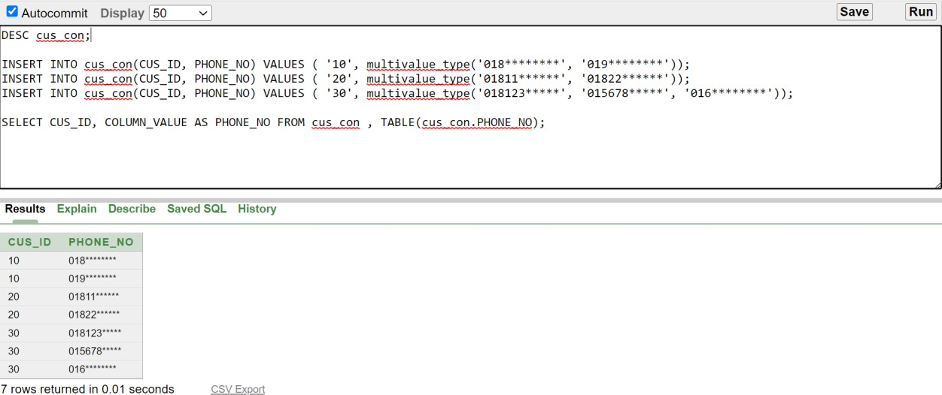
TABLE(cus_con.PHONE_NO);

Airline
desc Airline
insert into Airline( FLIGHT_NO, AIRLINE, CUS_ID) values('364', 'QUTAR', '10')
insert into Airline( FLIGHT_NO, AIRLINE, CUS_ID) values('365', 'QUTAR', '20')
insert into Airline( FLIGHT_NO, AIRLINE, CUS_ID) values('367', 'BIMAN BANGLA', '10')
delete from airline where fLIght_NO = '892TL' select * from Airline

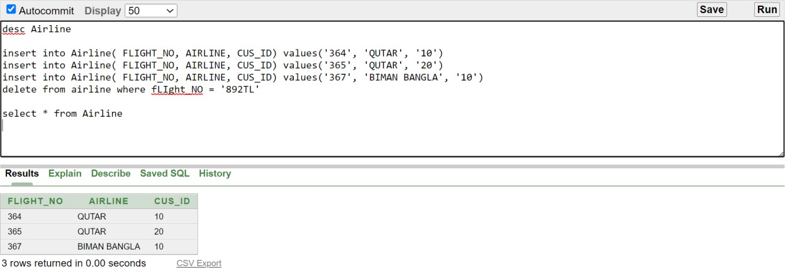

Airline_Info
desc Airline_Info

insert into Airline_Info( FLIGHT_NO, DEP_COUNTRY, ARR_COUNTRY, DEP_TIME, ARR_TIME) values('892TL','BANGLADESH','USA','26-NOV- 22','28-NOV-22')
insert into Airline_Info( FLIGHT_NO, DEP_COUNTRY, ARR_COUNTRY, DEP_TIME, ARR_TIME) values('367FC','USA','UK','03-MAY-22','04-MAY- 22')

select * from Airline_Info
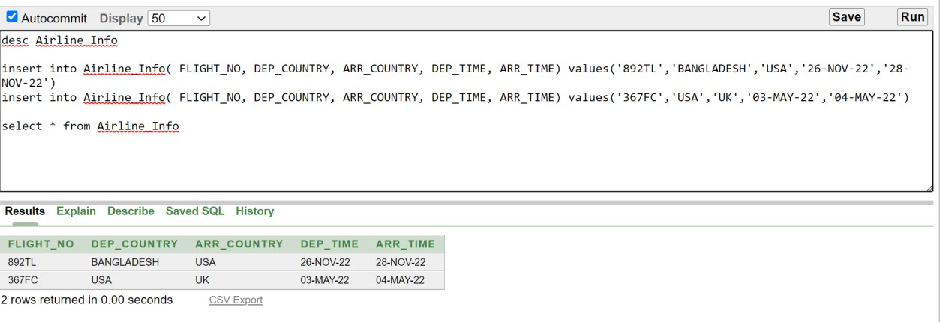

Transportation
DESC transportation
insert into transportation( TRANS_NO, BOOKING_DATE, PICK_LOC, DROP_LOC, MODE_OF_TRANSPORT, CUS_ID) values('T245GF','21-JUL- 23', 'UTTARA', 'KURIL','AC_CAR','10')
insert into transportation( TRANS_NO, BOOKING_DATE, PICK_LOC, DROP_LOC, MODE_OF_TRANSPORT, CUS_ID) values('F259OG','13- MAY-23', 'AZIMPUR', 'CUMILLA','AC_TRAIN','20')
insert into transportation( TRANS_NO, BOOKING_DATE, PICK_LOC, DROP_LOC, MODE_OF_TRANSPORT, CUS_ID) values('O2T59F','01-APR- 233','RAJSHAI', 'DHAKA','AC_BUS','30')
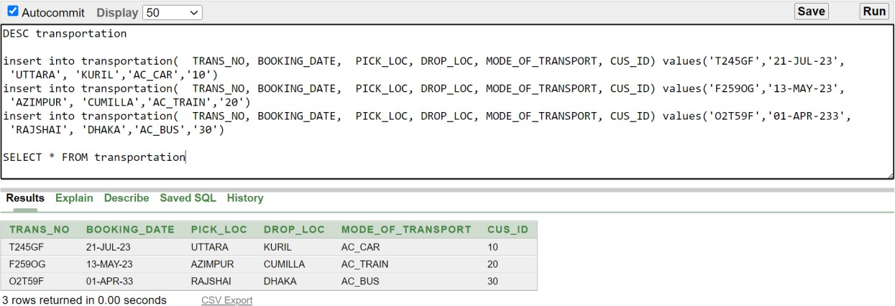
SELECT * FROM transportation

Hotel_Info
DESC Hotel_Info
insert into Hotel_Info (H_ID, H_NAME, LOCATION, FACILITES, CUS_ID) values('63K9','GHI', 'DHAKA', 'SWIMMING','10')
insert into Hotel_Info (H_ID, H_NAME, LOCATION, FACILITES, CUS_ID) values('26R0','BCD', 'CUMILLA', 'PARKING','20')
insert into Hotel_Info (H_ID, H_NAME, LOCATION, FACILITES, CUS_ID) values('55SK','JKL', 'MYMENSINGH', 'CONFERENCE','30')
SELECT * FROM Hotel_Info

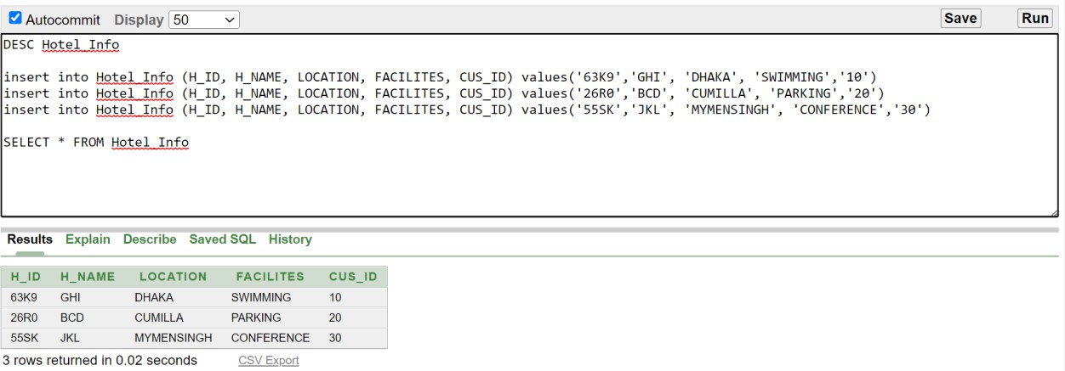

Accommodation
desc Accommodation;
insert into Accommodation( ACC_ID, IN_DATE, OUT_DATE, ROOM_TYPE, ROOM_NO, CUS_ID, H_ID) values('23-43','21-JUL-23', '24- JUL-23', 'SINGLE BED',501,'10','63K9')
insert into Accommodation( ACC_ID, IN_DATE, OUT_DATE, ROOM_TYPE, ROOM_NO, CUS_ID, H_ID) values('23-62','13-MAY-23', '16- MAY-23', 'DOUBLE BED',509,'20','26R0')
insert into Accommodation( ACC_ID, IN_DATE, OUT_DATE, ROOM_TYPE, ROOM_NO, CUS_ID, H_ID) values('23-65','01-APR-23', '10- APR-23', 'SINGLE BED',203,'30','55SK')

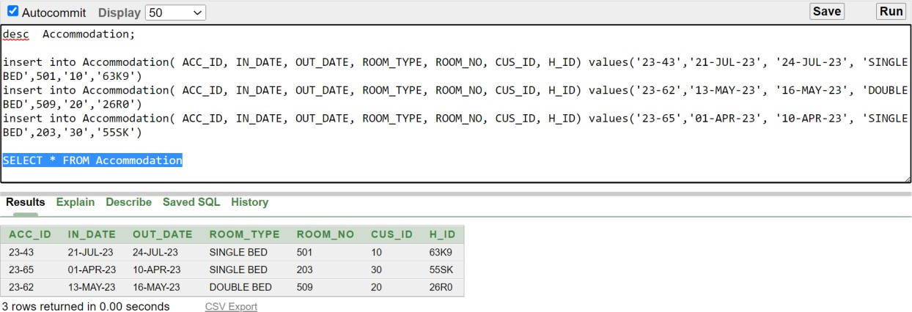
SELECT * FROM Accommodation

Food_Booking
desc Food_Booking
insert into Food_Booking( B_ID, B_DATE, MEAL_TYPE, N_O_GUESTS, H_ID) values('1001','22-JUL-23', 'LUNCH', '5','63K9')
insert into Food_Booking( B_ID, B_DATE, MEAL_TYPE, N_O_GUESTS, H_ID) values('2030','12-SEP-23', 'DINNER', '3','26R0')
insert into Food_Booking( B_ID, B_DATE, MEAL_TYPE, N_O_GUESTS, H_ID) values('3002','03-NOV-23', 'BREAKFAST', '6','55SK')
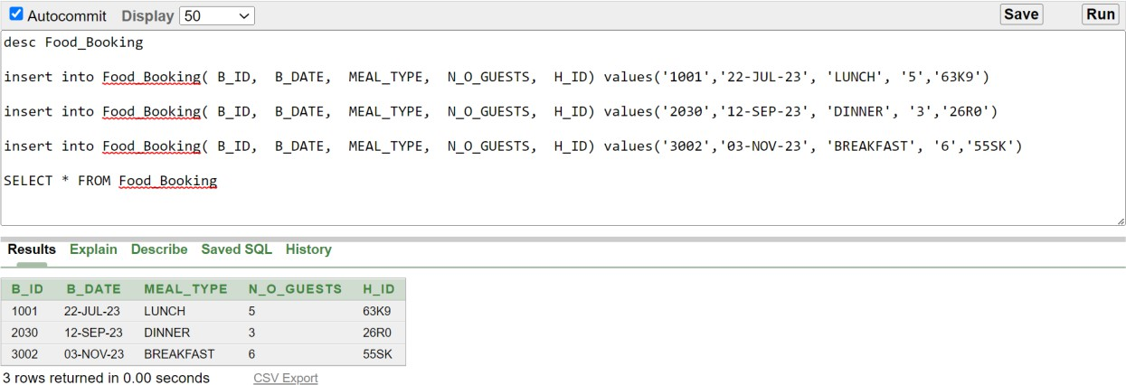
SELECT * FROM Food_Booking

Hotel_Ratings
desc Hotel_Ratings
INSERT INTO Hotel_Ratings(H_ID, RATINGS) VALUES ('63K9',
multivalue_type('GOOD', 'EXCELLENT'));
INSERT INTO Hotel_Ratings(H_ID, RATINGS) VALUES ('55SK',
multivalue_type('VERY GOOD', 'NOT BAD'));
INSERT INTO Hotel_Ratings(H_ID, RATINGS) VALUES ('26R0',
multivalue_type('EXCELLENT'));

SELECT H_ID, COLUMN_VALUE AS RATINGS FROM Hotel_Ratings,
TABLE(Hotel_Ratings.RATINGS);

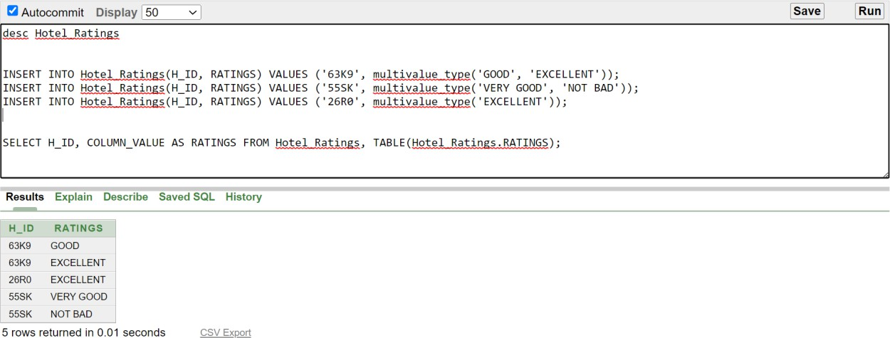

Payment
desc Payment

insert into Payment( PAY_ID, AMOUNT, PAY_DATE, PAY_METHOD, INVOICE_NUMBER, CUS_ID) values('507B', 2000,'10-JAN-23', 'BKASH', 984,'10')
insert into Payment( PAY_ID, AMOUNT, PAY_DATE, PAY_METHOD, INVOICE_NUMBER, CUS_ID) values('465C', 500,'11-JUL-23', 'NAGAD', 985,'10')
insert into Payment( PAY_ID, AMOUNT, PAY_DATE, PAY_METHOD, INVOICE_NUMBER, CUS_ID) values('203A', 5000,'23-DEC-23', 'CASH', 986,'10')
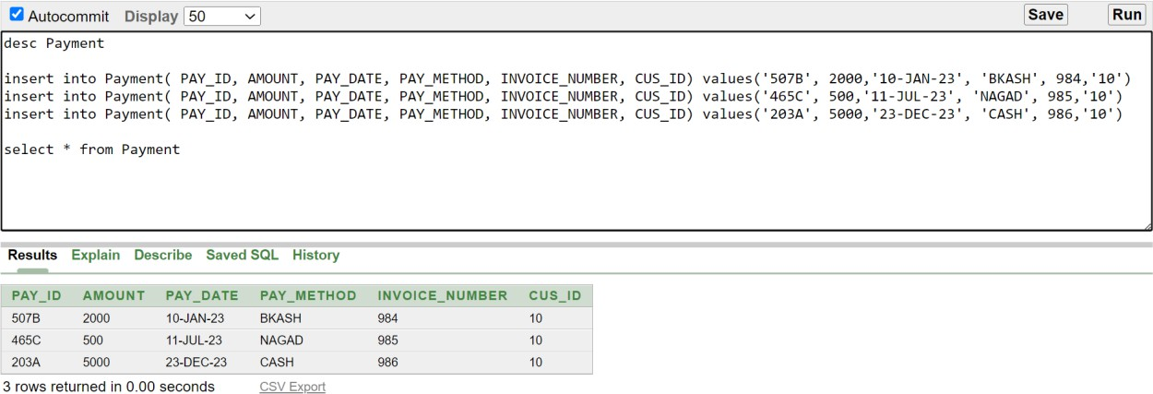
select * from Payment

QUERY WRITING:

Single Row Query

Q_01: Show employee ID, name, date of birth, job title and salary who earn less than 15000.
Query:
SELECT E_ID, E_NAME, DOB, JOB_TITLE, SALARY
FROM EMP_Info WHERE SALARY<15000
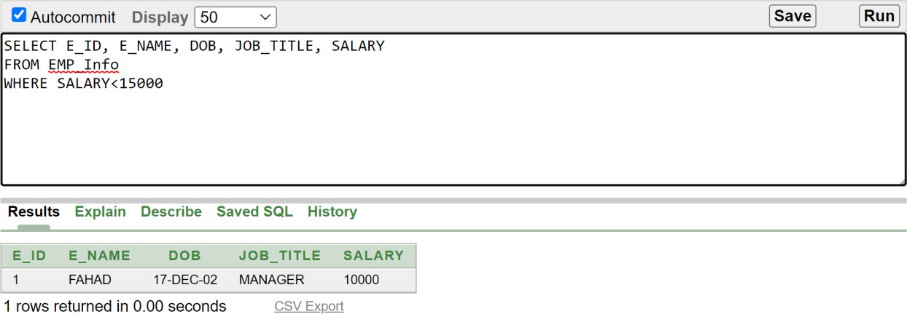

Q_02: Show check-in, check-out time, room type and room number of the customer who’s ID is 20.
Query:
SELECT IN_DATE, OUT_DATE, ROOM_TYPE, ROOM_NO, CUS_ID
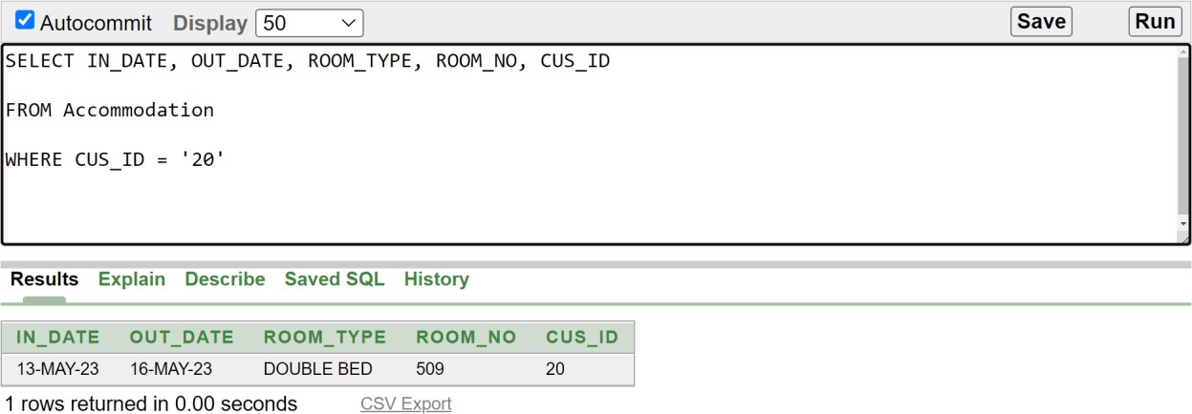
FROM Accommodation WHERE CUS_ID = '20'

Q_03: Show customer phone numbers who’s ID is 10.
Query:
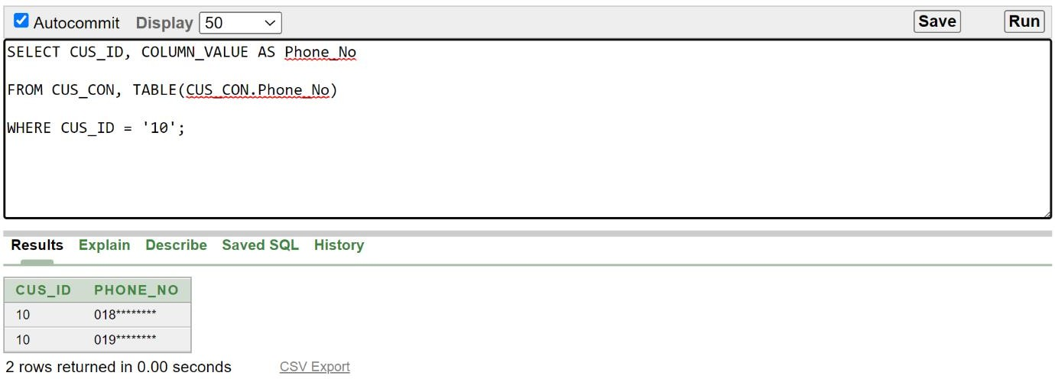
SELECT CUS_ID, COLUMN_VALUE AS Phone_No FROM CUS_CON, TABLE(CUS_CON.Phone_No) WHERE CUS_ID = '10';

Multiple Row Query

Q_04: Show invoice number and payment date where payment is maximum.
Query:
SELECT AMOUNT, INVOICE_NUMBER, PAY_DATE FROM PAYMENT
WHERE AMOUNT = (SELECT MAX(AMOUNT) FROM PAYMENT);
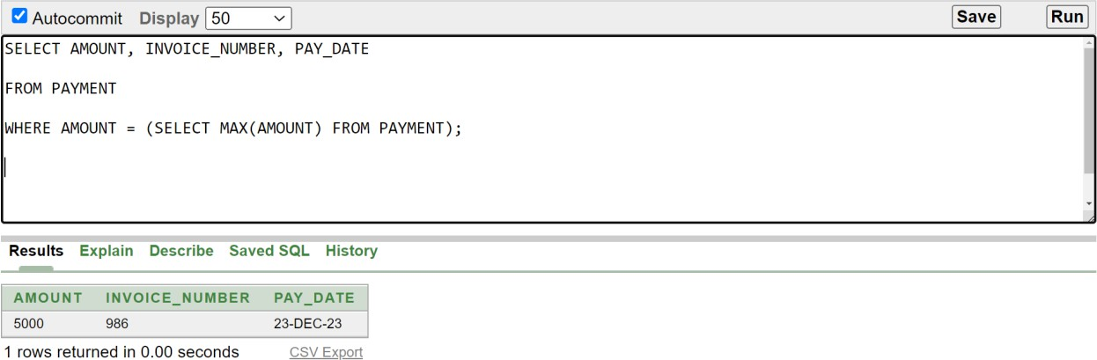

Q_05: Show the average salary based on agency company.
Query:
SELECT ROUND(AVG(SALARY),2) AS "AVERAGE SALARY", AGENCY_ID
FROM EMP_Info
GROUP BY AGENCY_ID
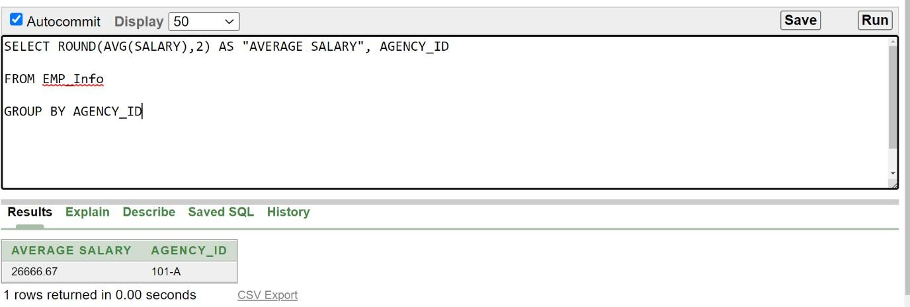

SUB QUERY

Q_06: Show all the customer’s information from ABC agency. If any customer does not have a membership, display their membership status as no membership.
Query:
SELECT CUS_ID, CUS_NAME, EMAIL, NVL(MEMBERSHIP_LEVEL,'NO MEMBERSHIP'), AGENCY_ID FROM CUS_INFO
WHERE AGENCY_ID = ( SELECT AGENCY_ID FROM AGENCY_INFO
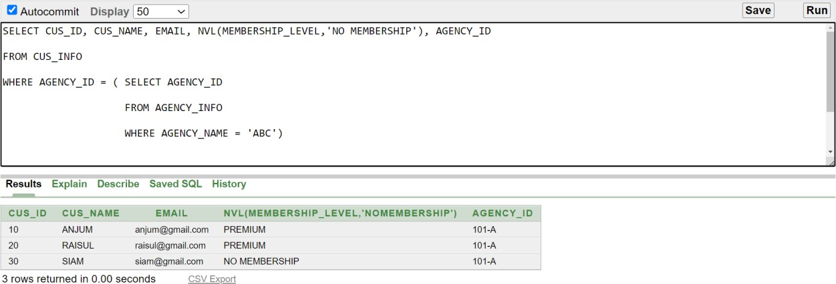
WHERE AGENCY_NAME = 'ABC')

Q_07: Show airline info for Raisul.
Query:
SELECT * FROM AIRLINE
WHERE CUS_ID = (SELECT CUS_ID FROM CUS_INFO
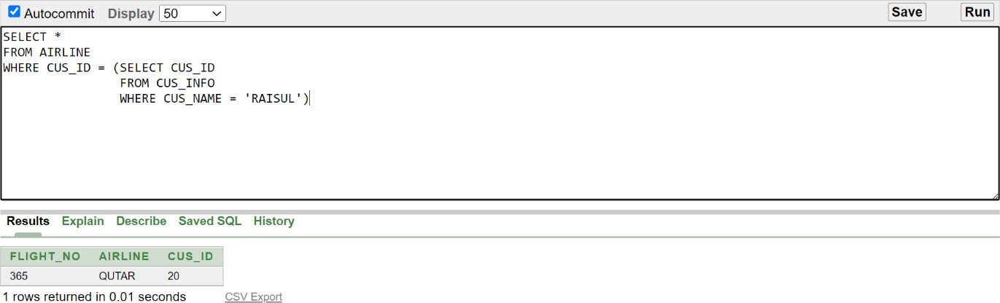
WHERE CUS_NAME = 'RAISUL')

  - JOINING QUERY

Q_08: Show transportation details for all customer.
Query:
SELECT C.CUS_NAME, T.*
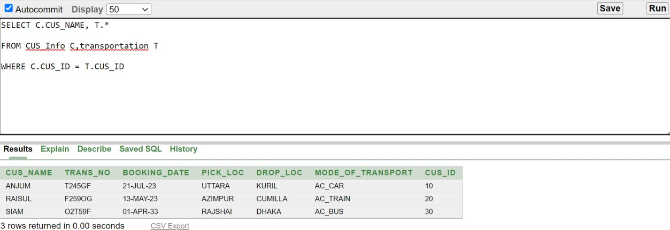
FROM CUS_Info C, transportation T WHERE C.CUS_ID = T.CUS_ID

Q_09: Show all the agency and their information which exists on this database.
Query:
select info.*, loc.*
from Agency_Info info, Agency_loc loc where info.agency_id = loc.agency_id

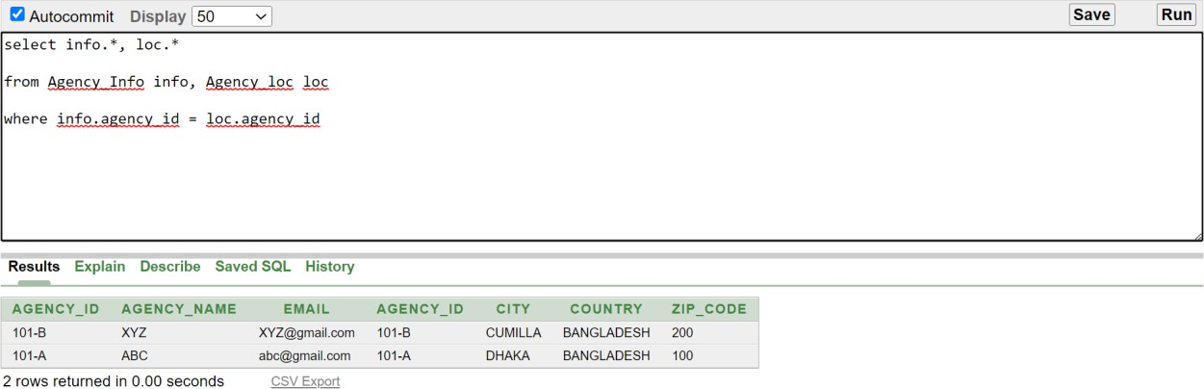

  - VIEW

Q_10: Create a view called transport based on the transportation no., pick-up location and drop location for customer ID 10.
Query:
create view transport
as select TRANS_NO,PICK_LOC, DROP_LOC from transportation
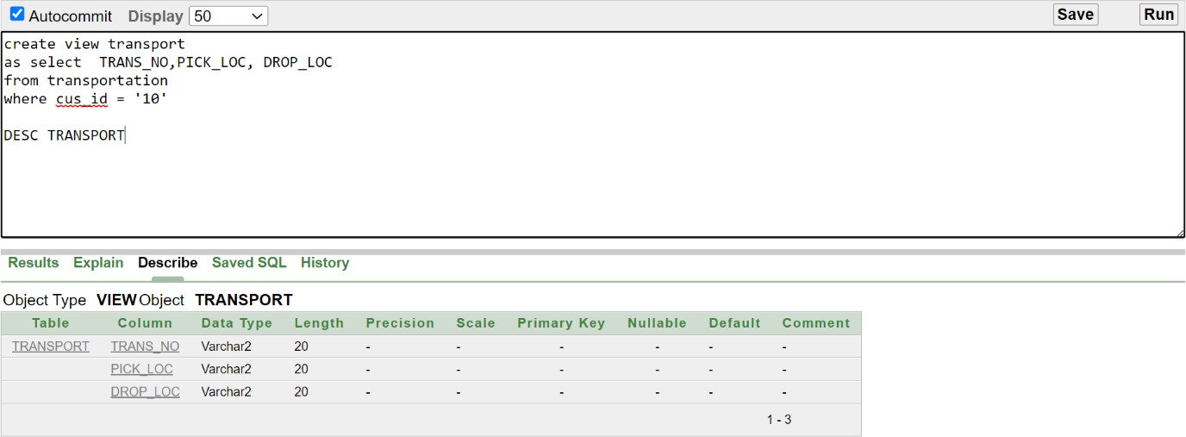
where cus_id = '10' DESC TRANSPORT

Q_11: Create a view named EMP_SAL that contains minimum salary and maximum salary according to agency ID. Level the columns name, MINSAL and MAXSAL.
Query:
create view EMP_SAL ( NAME, MINSAL, MAXSAL)
as select a.agency_name, min(e.salary), max(e.salary) from emp_info e, agency_info a
where e.agency_id = a.agency_id group by a.agency_name
DESC EMP_SAL

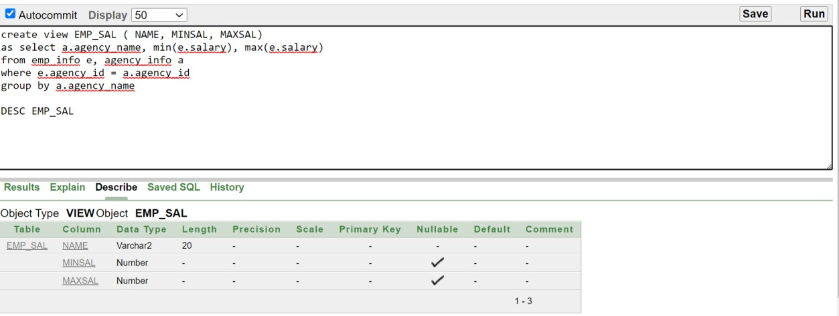

CONCLUSION:
Our project on tourism management system is built so that it can be used as a database schema of any travel management system. We tried to include all types of entities and store their information in the possible easiest way. Through this project, we have put our theoretical knowledge into a practical project that was learnt from this Introduction to Database course. The knowledge we gathered throughout this course and this project hopefully will help to build any projects related to databases we will have in the coming future. We are also very excited to work on this project and willing to add more features as well.

